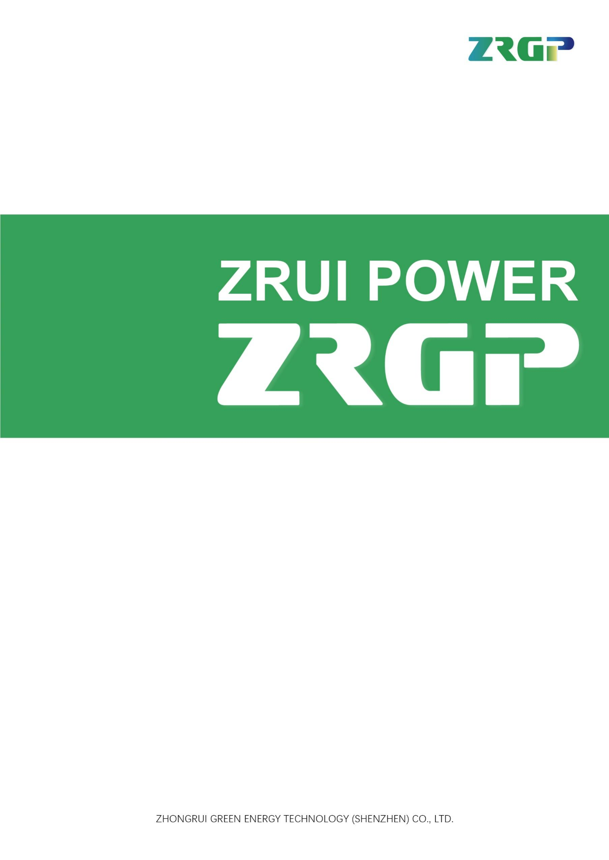
WARRANTY LETTER
这里填写公司名称或单位名称
相关单位
填写公司里的相关部门
相关部门
ZRGP WARRANTY LETTER

Applicable Area: [ ]
Applicable to sales from: [ ]

Applicable product types：

Product Name | Series Type

This limited warranty letter (herein after ”Warranty”) as described below applies to the energy storage application with (“Product”) supplied by ZHONGRUI GREEN ENERGY TECHNOLOGY(SHENZHEN) CO., LTD (herein after “ZRGP”) with the types referenced above to User via the way authorized by ZRGP. ZRGP warrants to the User as follows:

Warranty period
1.1 Product warranty
The warranty period of the product is 10 years.
The “Warranty Start Date” shall start either from the date after 4 months when product leaves the factory or the date when the product is registered on ZRGP server depending whichever comes earlier.
1.2 Capacity Performance warranty
ZRGP warrants that the Product will retain sixty per cent (60%) of its Usable Energy for ten (10) years from the Warranty Start Date; or reach the Minimum Throughput Energy, whichever comes first, on the condition that the Product is operated under a normal use followed by the manual provided by ZRGP.
1.3 The Minimum Throughput Energy
The Minimum Throughput DC Energy per kWh Usable Energy is 3.03MWh.
Remark: Capacity measurement condition is defined in Appendix 1.

Preconditions for warranty
  - The defect of the Product shall occur within the Product warranty period as determined above.
  - Any Product failure, fault or warning which had lead to system did not work or working abnormally, the relative information must be reported to ZRGP Authorized Service Partner within 30 days of appearance.
  - Product shall be installed by skilled personnel recognized or Partner certified by ZRGP.
  - End User shall correctly operate and use the Product according to User Manual and Installation Guidance provided against purchase.
  - End User shall provide the proof of the original purchase of the Product by presenting the seller’s invoice to the End User to ZRGP Authorized Service Partner.
  - The installation of the Product for the End User shall be completed within maximum 1 month from the Invoice Date.
  - The operating temperature during the operation of the Product must not exceed -10℃~50℃ temperature range and the Product shall not be exposed and stored in a temperature higher than 50℃, and shall not be exposed in an installed area to direct sunlight. The Product installation location must be ventilated in accordance with the requirements of User Manual and Installation Guidance.
  - This Warranty covers a capacity equivalent to one full cycle per day. The Product is not suitable for supplying life-sustaining medical devices and automotive application.
  - It is required that all the storage systems have internet connection for ZRGP CLOUD monitoring. Those systems that are not connected to internet, ZRGP CLOUD Limited Warranty for Storage System may become null and void.
- Replace or Repair
  - In the event that any Product covered by this Warranty and confirmed by ZRGP Authorized Service Partner to be defective or non-conformity, ZRGP will replace or repair the defective or non-conforming Product at its sole option and own discretion. Any maintenance or replacement shall not be deemed as extension or recalculation of the warranty period.
  - ZRGP will be responsible for the cost of repairing or replacing unqualified or defective products. The ownership of the replaced products belongs to the end user.
  - In some cases, products and related components may be discontinued. In this case, the latest batteries and parts or products may not be returned, but products with satisfactory quality and specifications will be provided for replacement.
- Exception of Warranty（Including but not limited to the following）
  - Warranty period specified above has already expired.
  - Product damage and defect caused by End User’s improper use, misuse, abuse, which non-conforming with User Manual.
  - Damage caused during transport, incorrect product installation, removal exceed of temperature range during use and improper use.
  - Unauthorized wiring and use with faulty or incompatible devices.
  - Product arbitrarily modified or its function changed without permission by ZRGP.
  - Any changes to the installation wasn’t done in accordance with the Installation Guidance.
  - Product damage caused by maintenance and other services conducted by personnel unauthorized by ZRGP.
  - User fails to provide correct product serial number or product serial number is undecipherable or has been modified without permission by ZRGP.
  - External influences including unusual physical or electrical stress (power failure surges, inrush current, lightning, flood, fire, accidental breakage, etc.)
  - Product damage caused by external force, force majeure (causes of natural disasters such as unforeseeable, unavoidable and insurmountable objective events, including but not limited to war, civil war, strike, riot or other activities intervened by government, terrorism, war, riots, strikes, unavailability of suitable and sufficient labor or materials and other events which are out of control of ZRGP) or other third party.
  - Product damage caused by End User deliberately or by willful act.
  - Product failure is not reported to ZRGP Authorized Service Partner within 30 days of appearance.
  - Purchase and installation of the Product in an area other than the applicable area.
- Non-Applicability of Warranty Claim
  - In case a warranty claim is reported which shows not to be valid, the costs incurred by ZRGP or ZRGP Authorized Service Partner due to this non-applicability of warranty claim shall be covered by End User.
- Applicable law
  - The product warranty is protected by the laws and regulations of PRC and the Applicable Area. If any provision of this warranty agreement is declared invalid or unenforceable by the court and administrative agency with jurisdiction, this provision is deemed to have been amended, and will obtain the same economic effect as the original provision of this warranty as far as possible, and will continue to take effect.
- Warranty Restriction
  - Unless otherwise specified herein, to the extent permitted by applicable law, the Warranty Letter and above remedies shall be exclusive and replace all other guarantees and remedies, oral or in writing, expressed or implied. To the extent permitted by applicable law, ZRGP expressly reject any and all legal or implied warranty, including but not limited to warranties of merchantability, fitness for a particular purpose and hidden or potential defects. If ZRGP cannot abandon implied warranty as prescribed by applicable law or the guarantee specified by applicable laws, all of such guarantees and warranties shall limit to implied warranty as prescribed by applicable law or the scope within applicable laws and shall be under mandatory application according to applicable law. No distributor, agent or staff of ZRGP and / or ZRGP Authorized Service Partner is authorized to make any revision, extension or addition to the quality warranty. The legality and enforceability of remaining clauses herein shall not be affected or damaged if any of clauses herein is adjudged to be illegal or unenforceable.
  - Unless otherwise specified herein, to the maximum range permitted by applicable law, ZRGP will not be liable for any direct, indirect, special, accidental or derivative losses caused by the purchase or use of Products and its system, including but not limited to the loss of use, loss in income, actual or expected loss in revenue ( including contract revenue losses ), loss of the use of money, loss of anticipated savings, loss of business, loss of opportunity, loss of goodwill, loss of reputation, personal injury or damage loss, or the indirect or derivative loss or damage ( including any expense arising from the replacement of equipment and property, resumption of production, etc. ) caused by any reasons.
  - ZRGP’s Liability from any cause whatsoever shall in no event exceed the amount of the purchase price paid by end user to ZRGP for such product giving rise to the liability. Excepted from this is liability on the grounds of culpable injury to life, Physical injury or injury to health and the mandatory liability from intent or gross negligence.
- Out of Warranty
  - In the event the Product is out of warranty, ZRGP may (in its discretion) provide certain after-sales service to End User, but all the costs and expenses, such as parts, labor costs, and travel expenses, shall be borne by End User. To request such after-sales service End User must provide sufficient information about any defects to enable ZRGP Partner to determine whether such defects are capable of repair.
- Dispute Resolution
  - In case of any dispute in terms of warranty-claims, a first-class international testing institute shall be entrusted by ZRGP and End User upon mutual consents in order to provide third party verification and comments. All fees and expenses shall be borne by the party that demanded such verification procedure, unless otherwise agreed.
The Hong Kong International Arbitration Centre shall have exclusive jurisdiction for further disputes about a warranty claim arising from this Warranty.

Appendix 1
- Capacity measurement condition:
Ambient temperature: 23℃~27℃, humidity: 25%~85%, atmosphere: 86kPa~106kPa
- Charge/Discharge method:
    - Discharge the battery with Constant current ( 0.5C ) until the battery reach End of discharge voltage or battery self-protection automatically.
    - Lay aside the battery for 10mins.
    - The constant current and constant voltage charging mode is adopted. The charging voltage is described in the 0.5C constant current charging specification, and then the constant voltage charging current is 0.05C.
    - Lay aside the battery for 10mins.
    - Discharge the battery with Constant current ( 0.5C ) until reach End of discharge voltage. Calculate discharged capacity. Monitor current timely. ( If it's constant current. )
    - Calculate formula is: Current Capacity = Discharge time × Constant current value.
    - Charge the battery with Constant current ( 0.2C ) and Constant charge voltage ( 56V ) until battery SOC=50%.

（Party A） （Party B）
（Duty） （Duty）
（Date） （Date）

